**CICD Pipeline**

* Download and install Virtual Box.
* Download cent OS-7 minimal ISO file.
* Add to Virtual Box.
* Create User e.g., Username: Jenkins Password: 4511.
* Don’t forget to on network during installation.
* After installation login to Jenkin user.
* Type command: “ip a”.
* It will show Ip Address.

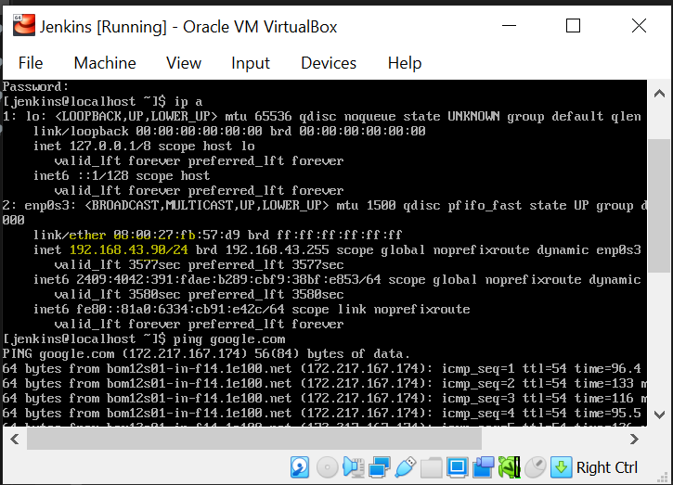

* Copy Ip Address.
* Download and install putty.
* Open putty

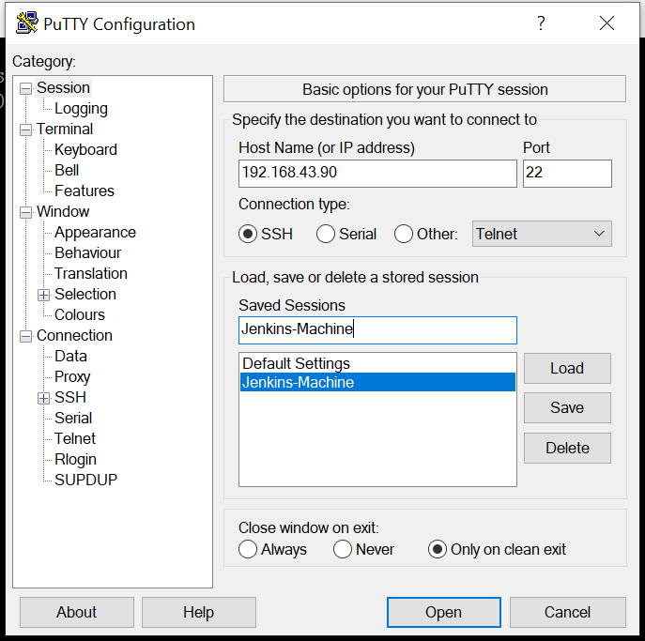

* Add copied IP address into Host Name, 22 will be default port use as it is.
* Select SSH
* Add name in Saved session e.g., Jenkin-Machine
* Click on Save
* Click on open
* Enter username and password in putty console. Username password is cent os virtual box’s username password.
* You can change font size. For that go to windows->Appearance->Change-> Select size e.g., 12.
* We are using this because it is simple to use putty instead virtual box. Putty gives us whole access of cent 0s 7 virtual box.
* Search on google docker for cent os.
* Follow steps from docker install cent os from docker website.
* sudo yum install -y yum-utils
* $ sudo yum-config-manager \
* --add-repo \
* https://download.docker.com/linux/centos/docker-ce.repo
* If you get error: jenkins is not in the sudoers file. This incident will be reported.

Solution: type cmd: 1: ssh root@localhost 2: sudo vi /etc/sudoers 3: type “i” for insert and enter 4: press esc button 5: type :x! and enter

sudo yum install docker-ce docker-ce-cli containerd.io

sudo systemctl start docker

* If we want to start docker whenever system reboot or restart please use below command.
* CMD: sudo systemctl enable docker
* Type CMD: docker ps (it will show multiple column e.g., CONTAINER ID IMAGE COMMAND CREATED STATUS PORTS NAMES) that means docker installed successfully.
* CMD: logout -> logout from active login on putty
* CMD: whoami -> to check username of system.
* If we got permission denied issue for any application on jenkin user or any user which open on putty then use below command:

e.g. docker having this issue in that case cmd is : “sudo usermod -aG docker Jenkins”

after typing this command logout and login again.

* Install docker compose.
* Search on google install docker compose
* Click on first link
* Select linux
* Copy and paste command from that site
* sudo curl -L "https://github.com/docker/compose/releases/download/1.29.2/docker-compose-$(uname -s)-$(uname -m)" -o /usr/local/bin/docker-compose
* Give executable permission to docker compose using below command.
* CMD: sudo chmod +x /usr/local/bin/docker-compose (+x means full permission)
* Type command: docker-compose
* If this command gave error run below
* sudo curl -L "https://github.com/docker/compose/releases/download/1.24.1/docker-compose-$(uname -s)-$(uname -m)" -o /usr/local/bin/docker-compose
* sudo chmod +x /usr/local/bin/docker-compose
* if it work it will show output like below

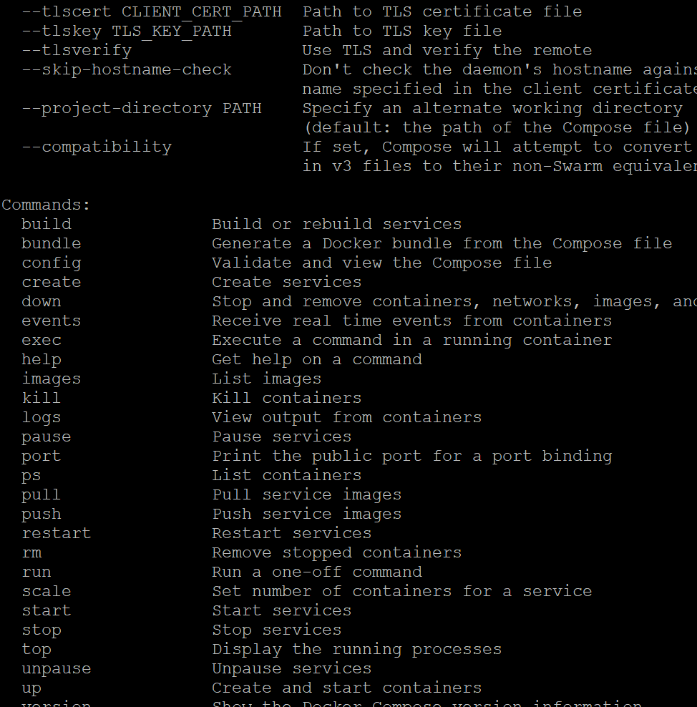

* **Downloading jenkin docker image.**
* docker pull Jenkins/Jenkins
* docker images
* docker info | grep -i root -> to locate docker folder where it saving files
* sudo du -sh /var/lib/docker -> will show how much space docker allocate
* **Create docker compose file for Jenkins**
* pwd-> current location
* cd-> change directory.
* ls-> list of files and folder in current directory
* ls -a -> list of files, folder and hidden item in current directory
* mkdir Jenkins-data-> to make directory with name Jenkins-data
* ll-> list of item with details.
* To change directory name: mv Jenkins/ Jenkins-data
* Create folder in home dir.
* In that folder follow below command.
* Docker compose file is like script. we define which service we using
* vi docker-compose.yml (name use as it is)
* Write below data into that file

**version '3'**

**services:**

**jenkins:**

**container_name: jenkins**

**image: jenkins/jenkins**

**ports:**

**- "8080:8080"**

**volumes:**

**- "$PWD/jenkins_home:/var/jenkins_home"**

**networks:**

**- net**

**networks:**

**net:**

* “echo” cmd used for print.
* Create docker container for Jenkins
* sudo chown 1000:1000 jenkins_home -R
* docker-compose up -d